**DAILY ONLINE ACTIVITIES SUMMARY**

|  |  |  |  |  |  |  |  |  |
| --- | --- | --- | --- | --- | --- | --- | --- | --- |
| **Date:** | **18/06/2020** | | | | | **Name:** | **POOJA D S** | |
| **Sem & Sec** | **4th Sem 'B' Section** | | | | | **USN:** | **4AL18CS056** | |
| **Online Test Summary** | | | | | | | | |
| **Subject** | | **……** | | | | | | |
| **Max. Marks** | | **30** | | **Score** | | | **……** | |
| **Certification Course Summary** | | | | | | | | |
| **Course** | **Blockchain Basics** | | | | | | | |
| **Certificate Provider** | | | **Great Learning Academy** | | **Duration** | | | **2.5 hour** |
| **Coding Challenges** | | | | | | | | |
| **Problem Statement:** A user will input two strings, and we find if one of the strings is a sub sequence of the other. Program prints “yes” if either the first string is a sub sequence of the second string or the second string is a sub sequence of the first string. Assume that, the length of the first string is smaller than or equal to the length of the second string. Assume that, the length of the first string is smaller than or equal to the length of the second string. | | | | | | | | |
| **Status: completed** | | | | | | | | |
| **Uploaded the report in Github** | | | | | **yes** | | | |
| **If yes Repository name** | | | | | <https://github.com/dspooja/C-coding> | | | |
| **Uploaded the report in slack** | | | | | **yes** | | | |

Online Test Details: (Attach the snapshot and briefly write the report for the same)

Certification Course Details: (Attach the snapshot and briefly write the report for the same)

Coding Challenges Details: (Attach the snapshot and briefly write the report for the same)

CERTIFICATION COURSE DETAILS:

* My Certification Course is Blockchain Basics.
* **The concepts covered in Blockchain Basics are:**
* Proof of work and stack
* Mechanism of Blockchain Transaction
* Blockchain Ecosystem
* Why Industries Need Blockchain

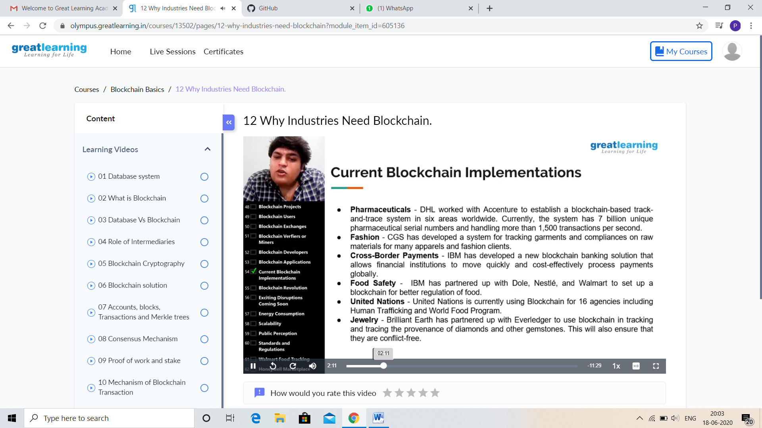

CODING CHALLENGES DETAILS:

Problem statement 1:

Write a C Program to generate first N Magic Numbers.

A magic number is defined as a number which can be expressed as a power of 5 or sum of unique powers of 5. First few magic numbers are 5, 25, 30(5 + 25), 125, 130(125 + 5), ….  
Input: n = 1  
Output: 5

Input: n = 2  
Output: 5 25

Input: n = 3  
Output: 5 25 30

Input: n = 8  
Output: 5 25 30 125 130 150 155 625

Solution: Uploaded in github.

